*Name: Tran Minh Triet (Thomas)*

*From: Ho Chi Minh, Vietnam*

**PROJECT: EXPLORE WEATHER TRENDS**

* Extracting data: I completed by code:
  + Data for my city: SELECT * FROM city_data WHERE city ='Ho Chi Minh City'
  + Data for global average: SELECT * FROM global_data
  + Data for other places:
    - Melbourne: SELECT * FROM city_data WHERE city = ‘Melbourne’
    - Hanoi: SELECT * FROM city_data WHERE city = ‘Hanoi’
    - Bangkok: SELECT * FROM city_data WHERE city = ‘Bangkok’
* Calculating moving averages: I used Excel to calculate the moving average with the interval of 3. I used the formula: =Average(array). Please see below:

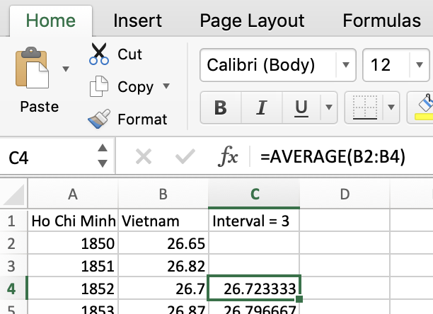

Then I drag down to the last row of data 🡺 I had the moving averages

I did same thing in global average:

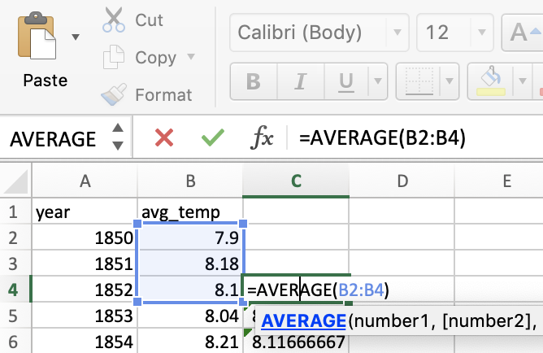

* Line chart:
  + Because data in Ho Chi Minh is no consistency so i decided to take data from 1850 to 2013 for both my city and global too.

My city (Ho Chi Minh – Vietnam)

And global:

* Base on the chart and data above:
  + My city (Ho Chi Minh – Vietnam) is hotter on average to the global average. And this is consistency for hundred years.
  + The changes in my city’s temperatures and global average over time are increasing.
  + Tempertures of Ho Chi Minh’s amplitude are higher than global average.
  + Overall trend look like increasing and getting hotter for both my city and global. Over last few hundred years, the trend has been consistent and maybe true for the future.
* The correlation coefficent is 0.84 🡺 strong relationship between my city’s temperatures and global average temperatures because it far from 0. (I calculated by using formula PEARSON of 2 array: Ho Chi Minh and global average)
* Some other cities:

Hanoi – Vietnam: : (correlation coefficient = 0.717)

Melbourne – Australia: (correlation coefficient = 0.609)

Bangkok – Thailand: (correlation coefficient = 0.82)

🡺 We can have conclusion that there is a strong relationship between cities in world and global average.